**Price Concession Policy**

***\*This is Tag Lending Group’s price concession policy. It must be scrupulously followed. No exceptions to the workflow are noted in this Policy because it would defeat TLG’s efforts to treat all requests equally and collect meaningful data on all requests, whether approved or denied.***

**WHAT IS A PRICE CONCESSION?**

Pricing Concessions/Exceptions (often referred to as **PEs**) are improvement adjustments that can be applied to pricing on most loan types. They are primarily issued for competitive reasons, to assist the borrower with closing costs, and/or to cure disclosure errors.

Loan Officer PE requests must be submitted online **via HubSpot** and will only be accepted and applied to the loan once the parent company has accepted the PE.

# REQUESTING A CONCESSION AT THE TIME OF LOCK

To lock your loan with a concession, select the “**Locked Rate**” button at the bottom of the Price Exception Form.

If a loan officer is requesting a concession at the time of lock, you will need manager approval, and the loan will be auto-locked. The concession will be put in a pending status until management has approved it. (Typically takes up to 30 minutes)

# PRICE CONCESSION REQUIREMENTS

* All data labeled with a red asterisk (*) on the Branch Price Concession request form must be completed to submit a PE request.
* All requests exceeding .50 BPTS require supporting documentation.
* Only the following forms of supporting documents will be accepted
  + A lock LE/CD from a competitor
  + A screenshot of an online lender’s rates/pricing. It must be a current rate quote comparing comparable market conditions to TLG’s quote and active in the borrower's market.
  + A screenshot of ‘Bank Rate’ or another aggregator that provides national rates and pricing.
  + An email from the borrower with specifics on the request for a price concession, i.e., the name of the competing lender, the amount of the requested concession, or mention of the competing rates/fees, etc.
* The following file types are supported for upload: .pdf, .doc, .docx, .txt, .tif, .jpg, .jpeg, .emf, and .xps.

**WHO IS AUTHORIZED TO REQUEST AND APPROVE CONCESSIONS?**

* All employees can use our pricing engine but must start by choosing "**Pricing Exception**" in HubSpot. Refer to the step-by-step flow chart below for guidance.
* Management and Team Leaders will approve concessions.

# TRACKING OF DENIED PRICE CONCESSIONS

Slack Channel “#**Secondary**” will show your approval or denial.

# STEP BY STEP CHART👇🏼

**Step 1:** Select the **Pricing Exception [BPS]** Property on the Deal left sidebar **OR** use the “**Pricing Exception**” Playbook

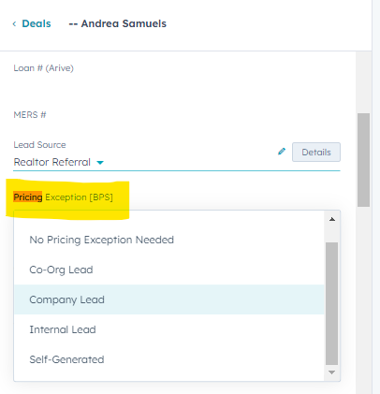 **OR** 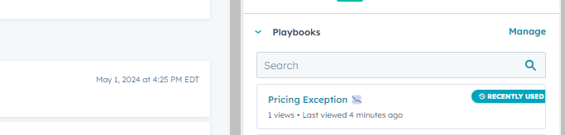

**Step 2:**

Check email/spam

**Step 3:**  
Fill out Form/calculations

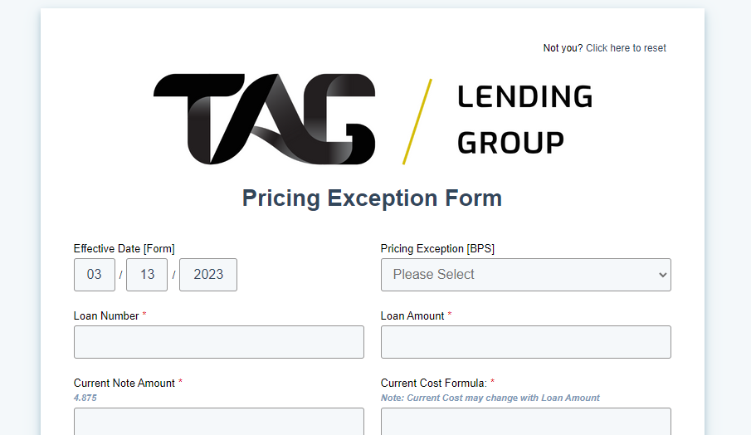

**Step 5:**

Select the type of PE

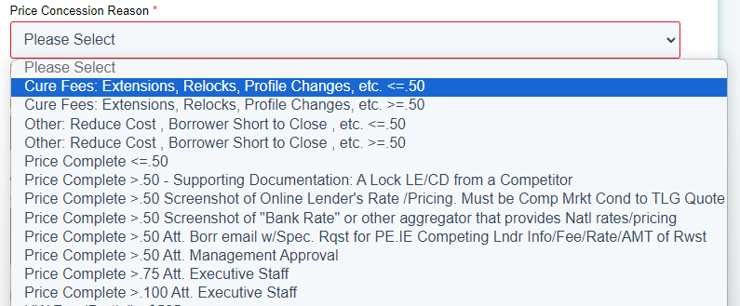

**Step 6:**

*Upload the mandated/necessary paperwork