**SEND the file to marketing**[**@taglendinggroup.com**](mailto:pearltagteamnation@gmail.com)**!**

* Computer **System Name**:

To get your System Name, Follow the steps below:

1. On your Computer Search button, type in “System Information”



1. Open this



1. You can find your system name as an example below and type it here

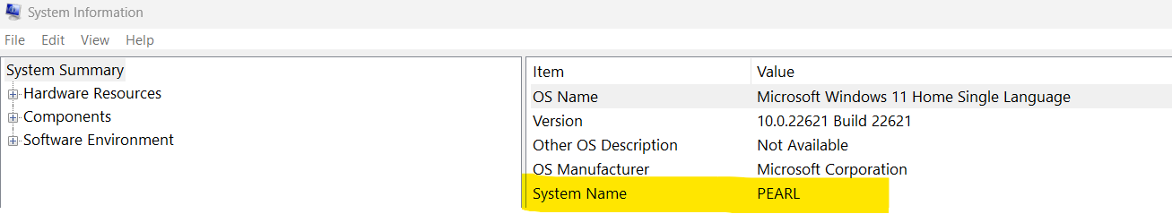

**START FILLING IN THE NECESSARY INFORMATION BELOW.**

* For your **Landing Page,** we will need the following:
  + **Short Description of yourself (minimum of 2 sentences):**

.

* + **What you do in the Company (minimum of 2 sentences):**
  + **What you can offer to your clients (minimum of 2 sentences):**

***Note: You can add anything essential to introduce yourself to your clients.***

* **Social Media Links (IF APPLICABLE)**
  + **Facebook**:
  + **LinkedIn** :
  + **Twitter**:
  + **Instagram**:
  + **Additional Links**: